CAF 2019: The Gershman Acoustics Room
Posted onNovember 12, 2019AuthorJackLeave a comment
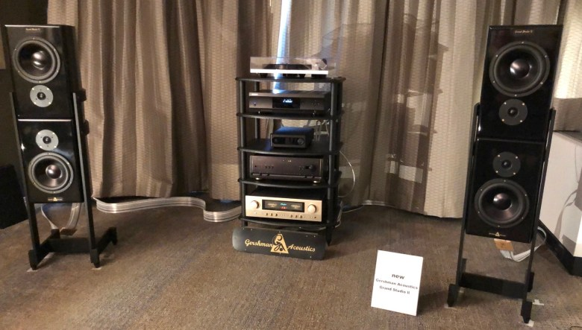
The Audio Hunters/Vinyl Revivers, a Simpsonville, MD, dealer teamed with Gershman Acoustics for this show. I heard and purchased my first Gershman speakers 19 years ago, a pair of Avant Gardes. Over the years, I have never heard a single pair of Gershman speakers that didn’t sound like music.
I think I have given them a “Room of Distinction” award at every show I have attended where they have used their POSH speakers. Reviewing the system they had at AXPONA this year, I said, “These have to be one of the best sounding and the best-looking speakers out there for under $20,000.” You can read that post here. Their room at CAF did not disappoint.

The System and The Sound
In the Gershman Acoustics listening room, they were using their new Grand Studio IIs. Don’t be misled by the picture, the speakers are not simply a stacked pair of speakers on each channel. Instead, they use a different cross-over for each speaker. The rest of the system was an Accuphase 270E integrated amplifier, Nordost Cables, a Naim transport, and a Bel Canto DAC.
The sound of these speakers has more of the essence of their top of the line POSH speakers than any of their speakers that I have heard. If you can’t tell, I really like these speakers. And I’m enjoying having a little Gershman in my house now as I’m currently reviewing a pair of their speakers. So, watch for that review soon.

